TC-DISP-015
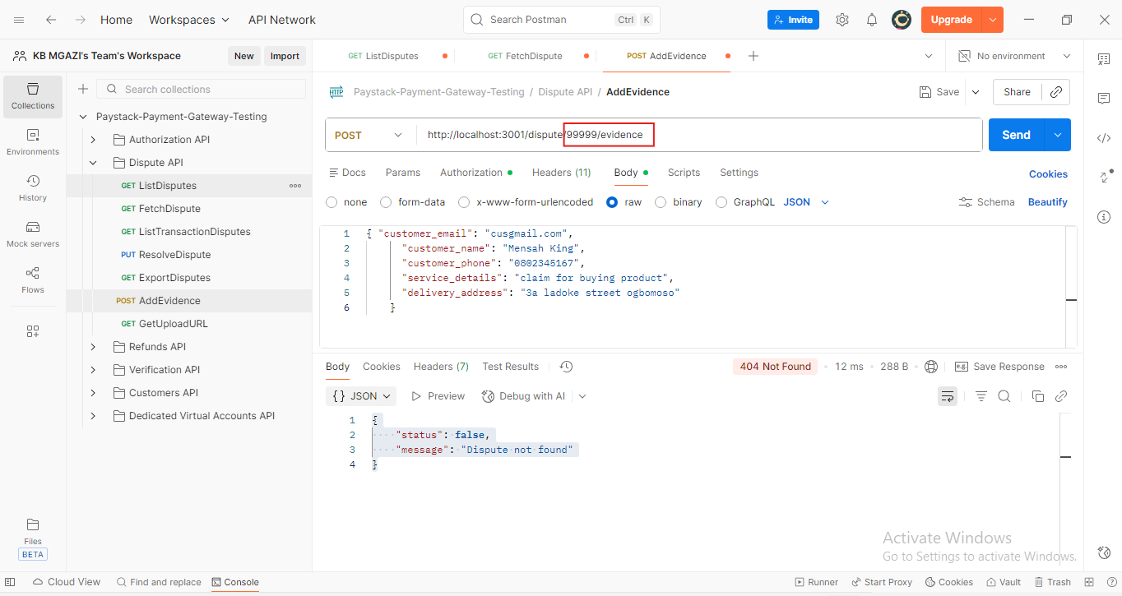
Request:
{ "customer_email": "cusgmail.com",
"customer_name": "Mensah King",
"customer_phone": "0802345167",
"service_details": "claim for buying product",
"delivery_address": "3a ladoke street ogbomoso"
}

Response:
{
"status": false,
"message": "Dispute not found"
}

